Class Guide: BTC220 – Classes 5 and 6
Instructors: Prof. Danilo T. Amaral, MSc João A. Teodoro
E-mail: danilo.trabuco@ufabc.edu.br, joao.teodoro@ufabc.edu.br

Class 5
Development of Potential Drugs as Novel Therapies – Case Study: Drug Redesign in Inflammatory Processes
–––––––––––––––––––––––––––––––––––––––––––––––––––––––––––––––––––––––––––
PDB: 8C3U
Sequence: APVRSLNCTLRDSQQKSLVMSGPYELKALHLQGQDMEQQVVFSMSFVQGEESNDKIPVALGLKEKNLYLSCLKDDKPTLQLESVDPKNYPKKKMEKRFVFNKIEINNKLEFESAQFPNWYISTSQAENMPVFLGGTKGGQDITDFTMQFVS (153 aa)
Ligand: T9C (S)-4'-hydroxy-3'-(6-methyl-2-oxo-3-(1H-pyrazol-4-yl)indolin-3-yl)-[1,1'-biphenyl]-2,4-dicarboxylic acid
–––––––––––––––––––––––––––––––––––––––––––––––––––––––––––––––––––––––––––
File format converter: https://www.cheminfo.org/Chemistry/Cheminformatics/FormatConverter/index.htmlhttps://www.cheminfo.org/Chemistry/Cheminformatics/FormatConverter/index.html

Part I – PDB and Protein Structural Analysis

- Open your preferred web browser and go to https://www.rcsb.org/;https://www.rcsb.org/

- In the search field, search for “8C3U”.
Note: Databases are updated daily; searches performed at different times may return different amounts of data.

- Click the protein entry “8C3U”.
Note: The next page displays information about the protein, including its class, organism, expression system, amino acid sequence length, molecular weight, and 3D structure resolution.

- Click “Download Files” and select “Legacy PDB Format”.
Note: The downloaded PDB file contains information such as the amino acid sequence.

- Go to https://molstar.org/viewer/ or https://open.playmolecule.org/ and upload the file downloaded in step 4.https://molstar.org/viewer/https://open.playmolecule.org/
Note: The downloaded “8C3U” file shows two protein molecules/chains and the structure of an antagonist (ligand/substrate). The two structures correspond to chains A and B (the same molecule associated with itself). To continue, download the provided PDB files (8C3U-protein.pdb and 8C3U-ligand.pdb).

- Download the PDB files provided on GitHub (8C3U-protein.pdb and 8C3U-ligand.pdb) and use these files for the following steps.

- Upload these new PDB files to https://molstar.org/viewer/ or https://open.playmolecule.org/ and inspect the 3D structure.https://molstar.org/viewer/https://open.playmolecule.org/

- Upload the newly downloaded structures and inspect them.
Note: Clicking any part of the structure displays the amino acid residue and the atoms of the molecule.

Part II – Binding Regions and Sites

- Go to https://durrantlab.pitt.edu/fpocketweb/ and upload “8C3U-protein.pdb”, downloaded earlier (Part I, step 6).https://durrantlab.pitt.edu/fpocketweb/

- Click “Start FpocketWeb” in the lower-right corner to begin the analysis.

- When the analysis is complete, the identified pockets will be displayed, along with a table containing information such as “score” and “druggability”.
Note: To display a pocket, click its name in the list.
NOTE: Select pockets with a druggability score > 0.500.

- Click “Download” to obtain a compressed (ZIP) archive containing PDB files.

- Extract the files.

- Create a folder (“Drug-Discovery-Data” or similar) and copy “8C3U-protein_out.pdb”, “pocket1_atm.pdb”, and “pocket2_atm.pdb” from the “pockets” folder.

- Go to https://molstar.org/viewer/ and open the downloaded files (steps 12 and 13).https://molstar.org/viewer/
Note: The newly displayed regions are those predicted to have better substrate/drug interactions and higher druggability.

- On the same website (https://molstar.org/viewer/), upload “8C3U-ligand.pdb” and check whether the ligand is located in either of the pockets (1 or 2) ranked highest by Fpocket.https://molstar.org/viewer/

- Go to https://sites.gatech.edu/cssb/FINDSITE-COMB-2/;https://sitHomees.gatech.edu/cssb/FINDSITE-COMB-2/

- Select “For virtual LIGAND screening”.

- Enter a name in “Sequence name”, provide your UFABC email address, and select the .pdb file of your target.
Note: Alternatively, use a FASTA sequence.

- HomeUpload the result to https://molstar.org/viewer/.https://molstar.org/viewer/

- Analyze the identified sites and determine whether any match the information from the previous files.

- Go to https://ftmap.bu.edu/login.php;https://ftmap.bu.edu/login.php

- Create/sign in to an account or choose “Use FTMap without your own account”.
Note: For this class, choose “Use FTMap without your own account”.

- Enter a “Job Name”, upload “8C3U-protein.pdb” under “Upload PDB”, and enter “A” for “Chain”.

- Click “Map”.

- Click the “ID” of your analysis (the first entry in the list).
Note: A list of analyses and their statuses will appear. Since this analysis takes time, download the provided “8C3U-ftsmap.pdb” file.

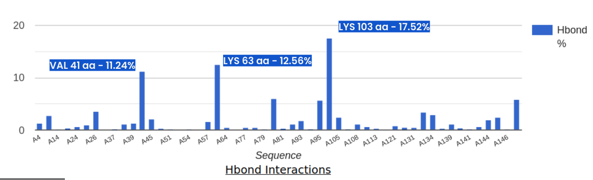
Note: FTMap results show residues with strong interaction affinity; typically, the highest percentages or values > 10% are selected.

Class 6
Part III – Databases and Molecular Docking

1. Access the ZINC database: https://zinc.docking.org/substances/home.
Note: Explore the database and examine previously studied and characterized compounds. You can filter compounds based on molecular weight, categories such as FDA-approved drugs, and other properties.
2. Access the DrugBank database: https://go.drugbank.com/drugs.
Note: Explore the database and examine known compounds. You can apply filters based on drug groups (e.g., Approved, Experimental), markets (USA, Canada, EU), molecular weight, and other characteristics.
3. Search for the following SMILES sequence:
Cc1ccc2c(c1)NC(=O)C2(c3cc(ccc3O)c4ccc(cc4C(=O)O)C(=O)O)c5c[nH]nc5
4. Examine the list of compounds retrieved from the search.
Note: Identify structurally similar compounds and check their classification tags, such as "Approved". This information may help identify potential alternative compounds with structural similarities to the reference molecule.
5. Download the previously selected substrates/ligands for subsequent analyses and save them in the "Substrate" folder.
Note: Divide the class into four groups, with each group responsible for analyzing one substrate/ligand: Ibuprofen, Prednisone, Acetylcarnitine, or Padimate O. Download the corresponding files in both .sdf and .smiles formats.

Molecular Docking
6. Access CB-Dock2: https://cadd.labshare.cn/cb-dock2/index.php and select the "DOCK" option.
Note: An alternative online molecular docking platform is HADDOCK 2.4 (https://rascar.science.uu.nl/haddock2.4/), which requires registration using an institutional email address.
7. Upload the target protein file in .pdb format and wait until the upload is complete.
8. Upload the substrate/ligand file in .sdf format and wait until the upload is complete.
9. Select the "Search Cavities" option.
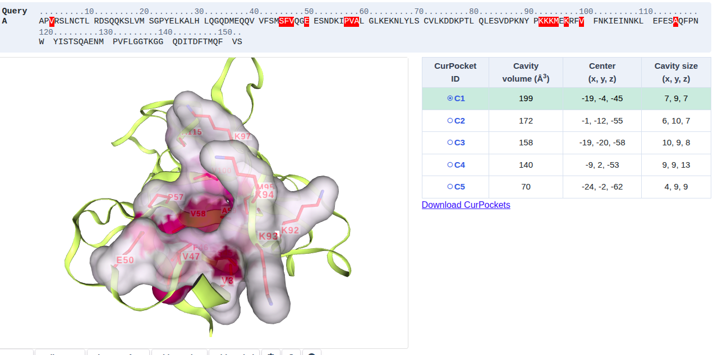
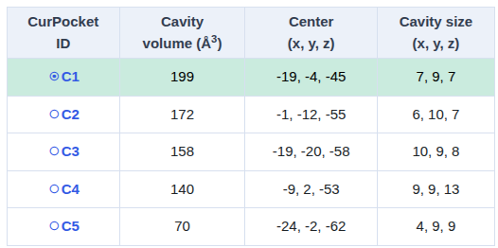
Discussion question (Query A): Why was only one cavity identified, and why were amino acid residues that are not spatially adjacent included in the predicted binding site?
10. Wait for the analysis to finish. Once completed, a results section will appear below the email field. Click "View Results".
Note: Perform the docking analysis for all four substrates: Ibuprofen, Prednisone, Acetylcarnitine, and Padimate O.
11. Examine the "CurPOCKET ID" table, which provides information about the predicted binding sites and ligand interactions.
Note: Alternatively, the results may be sent to the email address provided during submission. Open the corresponding link to access the results.
12. In "Contact View", identify the amino acid residues interacting with each ligand and examine the docking scores.
13. Download all available "CurPOCKET ID" results in PDB format (protein–ligand complexes).
14. Access the Mol* Viewer: https://molstar.org/viewer/ and compare the downloaded .pdb files with the reference structure vina_dock-T9C.pdb.
Note: Determine whether the new ligands interact with the same binding pocket or a region close to the reference ligand (vina_dock-T9C.pdb). The reference file will be provided by the instructor.
15. Select the ligand–protein complex with the most favorable docking score (more negative) and a binding position closest to the reference ligand.

Molecular Dynamics Simulations
16. Access the WebGRO platform: https://webgro.uams.edu/ProteinInWater/index.html.
17. Create an account or log in using your institutional email address.
18. In the "File Upload" section, upload the best protein–ligand complex (.pdb) obtained from the molecular docking analysis.
19. Configure the molecular dynamics simulation using the following parameters:
Section | Parameter | Setting
Input Parameters | Box Type | Octahedron
Energy Minimization Parameters | Steps | 10,000
Equilibration and MD Run Parameters | Simulation Time | 25 ns
Equilibration and MD Run Parameters | Approximate Number of Frames per Simulation | 5,000
20. Click "Submit" to start the molecular dynamics simulation.

Part IV – Toxicity, Pharmacokinetic Analysis, and Results

ADMETlab 3.0 Analysis
21. Evaluate the ligands selected in Part III using the ADMETlab 3.0 platform: https://admetlab3.scbdd.com/server/screening.
22. Upload the .sdf files obtained in Part III (Step 5), corresponding to the ligands with potential biological activity, and click "Submit".
Note: This analysis predicts pharmacokinetic properties, potential toxicity, bioavailability, and other relevant ADMET parameters (Absorption, Distribution, Metabolism, Excretion, and Toxicity).
23. Click "View" and examine the predicted results.

pkCSM Analysis
24. Access the pkCSM platform: https://biosig.lab.uq.edu.au/pkcsm.
25. Click "pkCSM".
26. Upload or enter the SMILES representations (.smiles) of the selected ligands.
27. Click "ADMET" and analyze the predicted pharmacokinetic and toxicity properties.

Final Results and Compound Selection
28. Compile and compare all results obtained from the molecular docking, molecular dynamics, and ADMET analyses.
29. Select the most promising substrate/ligand based on the following criteria:
- Molecular docking score: Identify the ligand with the most favorable (more negative) predicted binding affinity.
- Binding site: Evaluate whether the ligand interacts with the same or a nearby binding pocket as the reference ligand.
- Molecular dynamics: Assess the stability of the protein–ligand complex throughout the simulation.
- Pharmacokinetic properties: Compare the predicted absorption, distribution, metabolism, excretion, and bioavailability profiles.
- Toxicity: Identify potential toxicity risks and select compounds with more favorable predicted safety profiles.
30. Based on the combined computational results, determine which ligand represents the most promising candidate for further experimental investigation.

